# File permissions in Linux

## Project description

The research team at my organization do not have the correct file permissions, which leaves certain files and directories vulnerable to unauthorized access. For this project I will be using bash commands such as ls, chmod, cd and etc. to update file permissions, ensure the users on this team are authorized with the correct permissions in order to keep the system secure.

## Check file and directory details

First using the ls and cd commands, we want to go to the correct directory. We then use ls –l to looks at all the permissions for the files in the projects directory.

## Describe the permissions string

Using the ls -l command on the bash shell will return a permission string for each file and directory in the current directory that you are currently in. This string will show the read, write and execute permissions for the Users, Groups and Others.



For example, the project_k.txt file has a permission string, -rw-rw-rw-, the first character tells us it’s a file (-) if this was a directory it would start with dr. The first 3 characters are the permissions for the users, the next 3 are permissions for the group and the final 3 are the permissions for others. In this case these file permissions are:

* project_k.txt
  + User = read, write,
  + Group = read, write
  + Other = read, write

## Change file permissions

Now that the we have the file permissions for all the files in projects, the organization has made it clear that none of these projects are allowed to have write permissions for other users. Therefore, we will use chmod to change these permissions.

As you can see the write permission for the project_k.txt has now been removed.

Also the project_m.txt is a restricted file that should not be read or modified by the group or others, only the users are allowed these permissions. Therefore we must remove the read permission that the group has for that project using chmod.

## Change file permissions on a hidden file

To see all the hidden files and their permissions we will use the command ls -la.

We can identify that the .project_x.txt file is hidden, it is archived by the organization and should not be modified by anyone, but the users and groups should still be able to read the file.

You can now see using the chmod command we have removed the read and write permissions for group and users and added a read permission for the groups for the .project_x.txt file.

## Change directory permissions

Now for drafts directory, only the research 2 user should be allowed to access the drafts directory and its contents.



We can see that the groups have execute permissions which should not be there. We will use chmod to remove this.

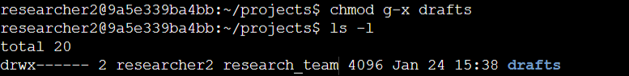

## Summary

Using Bash commands like ls and chmod, I updated permissions to secure files and directories. Key changes included:

1. **Files**: Removed write permissions for Others (e.g., project_k.txt) and restricted read/write access to Users only for sensitive files (e.g., project_m.txt and .project_x.txt).
2. **Directories**: Removed execute permissions for Groups on the drafts directory, allowing access only to a specific user.

These changes ensured compliance with the principle of least privilege and enhanced security.